Homework 10

Note: You can use dynamic array or static array in the following problems.

But dynamic array prefer)

Problem 1: Design a program to simulate 100 rolls of a six-sided die:

Count the number of times each side of die appears and for

each count use “*” to print out. Set the seed in srand() to 12345.

**Input/Output Example:**

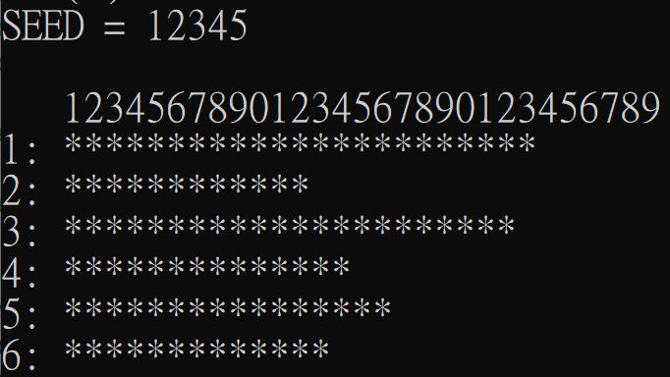

Problem 2:

We have the following score data, the last one represents the end of mark, not the data. 72,23,38,86,62,29,99,96,67,78,87,76,65,58,86,69,93,34,45,55

52,7,74,48,83,39,90,18,82,26,65,53,39,96,66,-1

(a). Calculate the average score of the data.

(b). Count the number of data in each interval. The difference between each interval is 10 point. ( 統計各區間人數, 區間差距為10分) That is

0~9, 10~19, 20~29, 30~39, 40~49,50~59, 60~69,70~79, 80~89, 90~100

(c). Count the number of data above the average and below the average.

(d).The output format will be:

**Input/Output Example:**

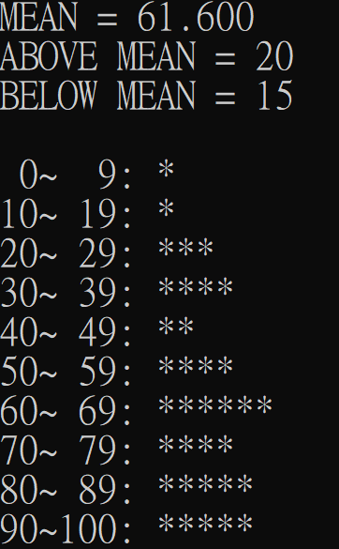

Problem 3:

Write a program: Using dynamic array only.

1. reads the row “r” and the column “c” of one matrix.

2. reads r x c number of integers,

3. stores these integers in one r x c array,

4. displays the sum of all its elements,

5. display the sum of each row’s elements,

6. display the sum of each column’s elements.

Let the program stop when inputting CTRL+Z.

**Input/Output Example:**

>>>>Enter r and c: 3 2

Please input the elements of matrix:

1 2 3 4 5 6

The matrix:

1 2

3 4

5 6

sum all: 21

sum of row 0: 3

sum of row 1: 7

sum of row 2: 11

sum of column 0: 9

sum of column 1: 12

>>>>Enter r and c: ^Z

Problem 4:

A robot can take steps of 1meter, 2 meters. Write a function that lists all of the ways that the robot can walk n meters. Let the user input n, and stop the program when inputting CTRL+Z.

**Input/Output Example:**

Please input n meters: 6

1 1 1 1 1 1

1 1 1 1 2

1 1 1 2 1

1 1 2 1 1

1 1 2 2

1 2 1 1 1

1 2 1 2

1 2 2 1

2 1 1 1 1

2 1 1 2

2 1 2 1

2 2 1 1

2 2 2

Please input n meters: ^Z

Problem 5:

In linear algebra, a matrix is called a Toeplitz matrix when the elements of each diagonal parallel to the main diagonal are equal between each other. For example, the following 5x5 matrix demonstrates the generic form of a 5x5 Toeplitz matrix:

T = $\left[\begin{aligned}a b c d e \\ f a b c d \\ g f a b c \\ h g f a b \\ i h g f a\end{aligned}\right]$

Write a program that reads 5 integers and stores them in the first row and first column of a 5x5 array. Next, the program should create the Toeplitz matrix and display its elements. Let the user input n, the size of n x n array, and stop the program when inputting CTRL+Z.

**Input/Output Example:**

>>>Enter n: 5

Enter num: 1 2 3 4 5

The matrix:

1 2 3 4 5

2 1 2 3 4

3 2 1 2 3

4 3 2 1 2

5 4 3 2 1

>>>Enter n: ^Z

Problem 6:

Find specified-length palindromic sequences of nucleotide pairs in a portion of a DNA molecule whose complementary strands are represented as strings. Note that palindromic regions are of great interest to researched studying the transmission of the genetic information encoded in DNA.

Although we recall that a palindrome is a string that reads the same forward and backward, such as “Madam, I’m Adam” or “Able was I ere I saw Elba”, we must first see how closely this definition applies to the palindromes of DNA molecules.

DNA is a double-stranded molecule composed of pairs of the nucleotide Adenine, Thymine, Cytosine, and Guanine. Adenine always pairs with Thymine and Cytosine pairs with Guanine. The following figure shows a portion of a DNA molecule in which the complementary strands are ATCGCAT… and TAGCGTA…

A-T-C-G-C-A-T-G-C-G-T-A-G

T-A-G-C-G-T-A-C-G-C-A-T-C

The molecule portion shown contains a palindromic sequence of 8 nucleotide pairs. This region is palindromic because the sequence of nucleotides along the top strand, C-G-C-A-T-G-C-G, is exactly the reverse of the sequence along the bottom strand, G-C-G-T-A-C-G-C.

Given string representing the complementary strands and a length value, find all palindromic sequences of the specified length. Let user continuously input until Ctrl+Z

**Input/Output Example:**

Enter on strand of DNA molecule segment:

ATCGCATGCGTAG

Enter complementary strand:

TAGCGTACGCATC

Enter length of palindromic sequence: 8

The DNA:

ATCGCATGCGTAG

TAGCGTACGCATC

Palindromes of length is 8

Palindrome at position 2

CGCATGCG

GCGTACGC

=================

Enter on strand of DNA molecule segment:

^Z